|  |  |  |
| --- | --- | --- |
| **SANTA CLARA UNIVERSITY** | **ELEN 115**  **Spring 2023** | **Shoba Krishnan** |
| **Laboratory #4: Diode Basics** | | |

**I. OBJECTIVES**

* To study the diode i-v curve, and compare the characteristics to a piecewise linear model.
* To study the characteristics and performance of an LED
* To study diode applications, simulate them to verify operation and analyze performance.

**III. LAB PROCEDURE**

**Section A: Simulations**

1. **IV curve of a diode:** 
   1. Pick the diode 1N4148 from the library.
   2. Connect a DC voltage source across the diode.
   3. Run a DC sweep of the source voltage from -2V to 2V and measure the current through the diode.
   4. Plot the i-v curve of the diode and make observations of when it turns “ON”.

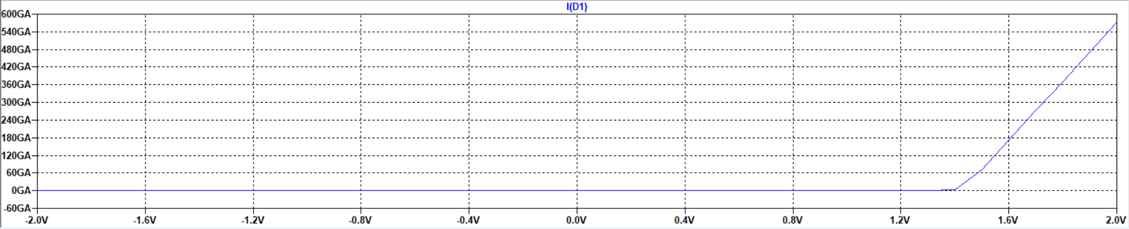

|  |
| --- |
| ***TA Check Point: Complete Part 1 and show your TA that the library component is working correctly.*** |

1. **Piecewise linear (PWL) model of a diode:** 
   1. Create a piecewise linear model for the 1N4148 diode as shown in Figure 1. Indicate the VD0 = 0.7V and rD = 5ohms. Create the circuit using a voltage source, resistor, and an ideal diode as in the figure below.

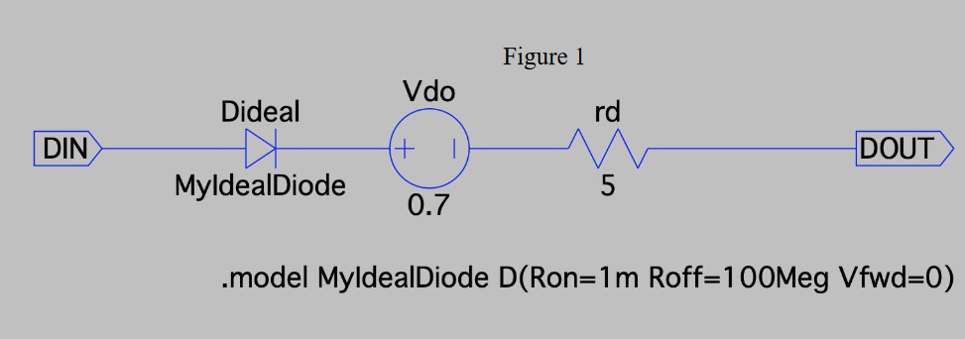

For the diode model use the below script.

**.model MydealDiode D(Ron=1m Roff=100Meg Vfwd=0)**

* 1. Connect a DC source to this diode model.
  2. Run a DC sweep of the source voltage from -2V to 2V and measure the current through the diode model.
  3. Plot the i-v curve of the diode model. Overlay this curve on the 1N4148 i-v curve.

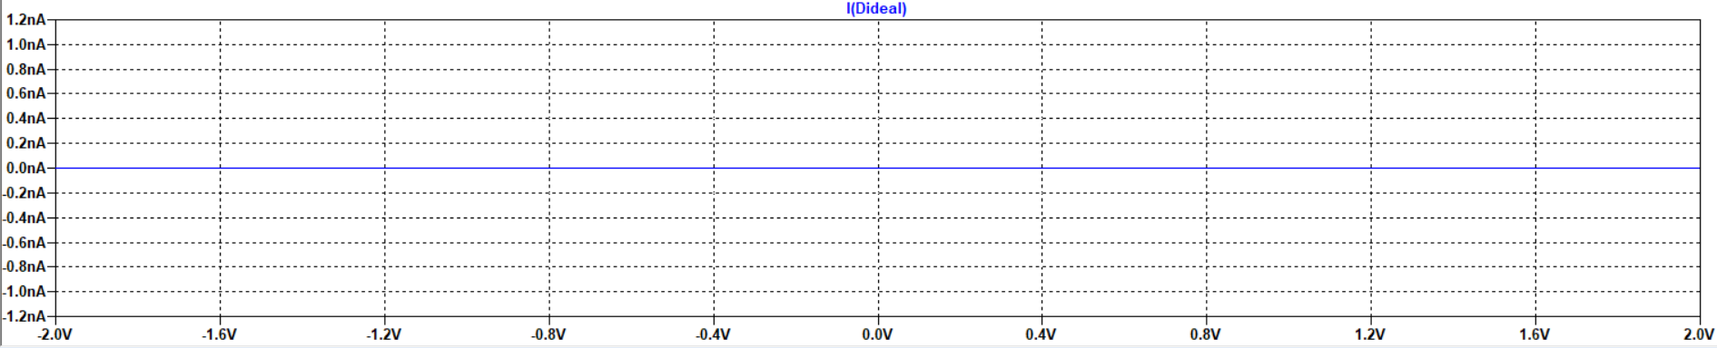

(v) Is the PWL model a good representation of the actual diode. Explain your answer.

**No, since the real diodes have many external factors, e.g., forward voltage, reverse voltage, forward current, reverse current, etc.**

**On the contrary, ideal diodes have a characteristic that exhibits short circuit for the forward voltage and open circuit for the reverse voltage. It is far too perfect compared to what diodes are possible in real life.**

(vi) Change the parameters VD0 and rD to see how to get closer to the actual i-v curve of the 1N4148 diode. Note these new values.

|  |
| --- |
| ***TA Check Point: Complete Part 2 and show your TA that the PWL model matches the 1N4148 i-v curve.*** |

1. **Diode Clamp Application** 
   1. Draw the circuit in Figure 2 with the transmission line replaced by an RLC circuit shown below. **DO NOT place the clamping diodes yet.**

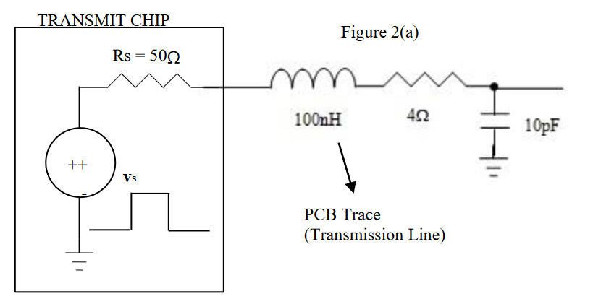

* 1. Give a square wave with duty cycle of 5% and voltage range 0 to 2.5 V and frequency 1kHz to this wire. Run simulations for 2msec with rise time 10psec and fall time 10ps.

(iii) Plot the input and output on one plot and explain the output signal you observe.

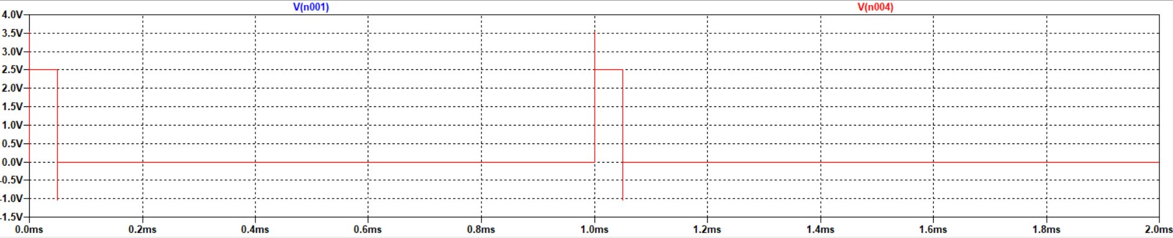

* 1. Place the ideal diodes you have made as clamps as is in Figure 2(b) and plot the result on the same plot. Explain the result of this clamping action.

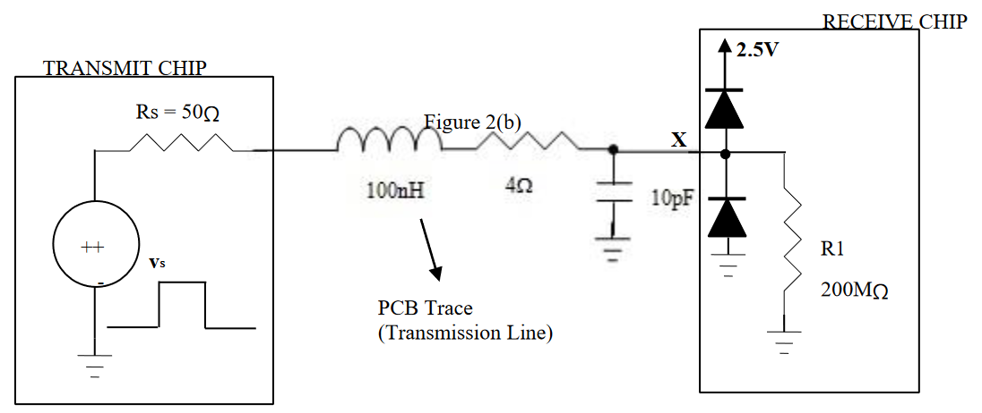

* 1. Replace the ideal diodes by the real diodes (1N4148) from the library and plot the result on the same plot. Explain the result of this clamping action. Is the voltage range of the clamp function appropriate?

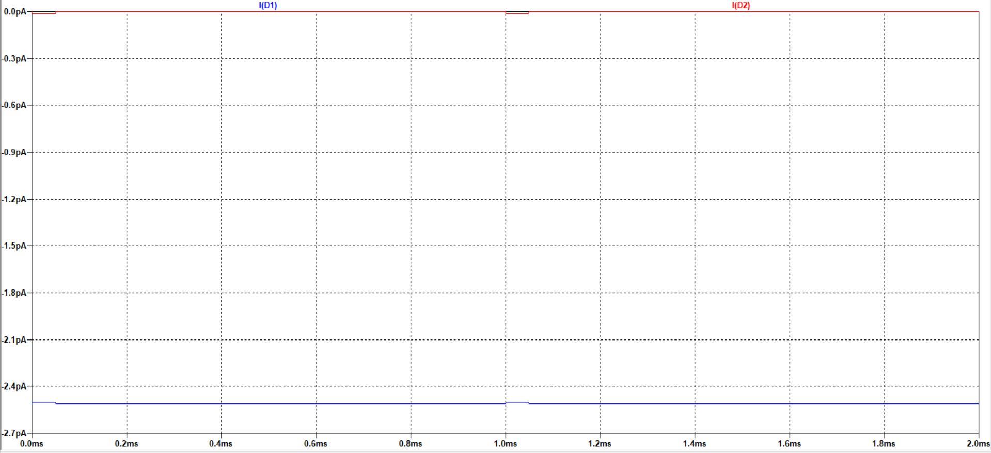

$$V_{A1}>V_{C1}+V_{DO}$$

In all cases: $V_{AI}=V_{IN}$

Ideal diodes would see $V_{DO}=0 V$

$$V_{IN}>2.5+0$$

Meanwhile:

As per the Diode 1N4148 Specs Sheet:

Forward drop voltage: $V_{DO}=1 V$

As a result:

$$V_{A1}>V_{C1}+V_{DO}$$

$$V_{IN}>2.5+1$$

$$V_{IN}>3.5$$

The clamping action would be implemented only if the Voltage Input is higher than 3.5 V, instead of the ideal version of 2.5 V.

* 1. If a diode is chosen with forward drop of 0.2V will that improve the clamp performance?

Forward drop voltage becomes: $V_{DO}=0.2 V$

As a result:

$$V_{A1}>V_{C1}+V_{DO}$$

$$V_{IN}>2.5+0.2$$

$$V_{IN}>2.7$$

The clamping action would be executed at a lower voltage: 2.7 V, rather than 3.5 V as per the Diode 1N4148 Specs Sheet.

|  |
| --- |
| ***TA Check Point: Complete Part 3 and show your TA that the clamps are functioning correctly.*** |

**Section B: Experiments**

1. **Working with LEDs:**

**Design:**

* 1. Design the schematic of Figure 3 that uses the LED whose data sheet was provided to you. From the data sheet pick an operating point to ensure the LED lights up.
  2. You will connect a DC source of 5V to the circuit of Figure 3.
  3. Determine the value of resistance R in Figure 3 to ensure the LED functions at that operating point.

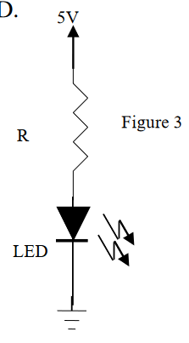

**Measurement:**

* 1. Measure the current flowing in the LED and the voltage drop across the 5 V LED. What is the operating point of your LED?

Is it similar to the one you designed?

Explain why or why not.

**The operating point of my LED is about 4.8 V.**

**It is similar to the one that I designed.**

* 1. What is the power dissipated in this circuit?

In order to find the power dissipated, we have to find the power table:

|  |  |  |  |  |
| --- | --- | --- | --- | --- |
| **Element** | **Voltage (V)** | **Current (mA)** | **Resistance (Ω)** | **Power (W)** |
| 100-Ω Resistor | 5 |  | 100 | 0.25 |
| 5-V LED | 5 | 20  (Forward Current) |  | 0.10 |
| **TOTAL (Power Dissipated)** | | | | 0.35 |

* 1. What is the power dissipated in the LED?

Does it meet the ratings as stated in its datasheet?

**As per the power table above, the power dissipated in the LED is 100 mW, which meets the ratings as stated in its datasheet.**

* 1. Vary the DC voltage source such as increasing it to 6V LED or dropping it to 4V. What do you notice?

Explain your observation.

**I noticed that by increasing it to 6V, the Power Dissipated will be higher, and dropping it to 4V will make the Power Dissipated lower.**

**However, whether they meet the ratings or not depends on datasheets for those respective LEDs, since they might have different datasheets, requirements, and other specifications.**

***TA Check Point: Complete Part 4 and show your TA that the LED will function correctly.***

1. **iv curve of a DIODE:** 
   1. Use the curve tracer in the lab to plot iv curves of the various diodes given to you.
   2. Note down the i-v curves of the various diodes you measure.

|  |
| --- |
| ***TA Check Point: Complete Part 5 and show your TA that you are proficient in using the curve tracer.*** |